**Assignment**

* *Generate code to fetch weather data securely without exposing API keys in the code.***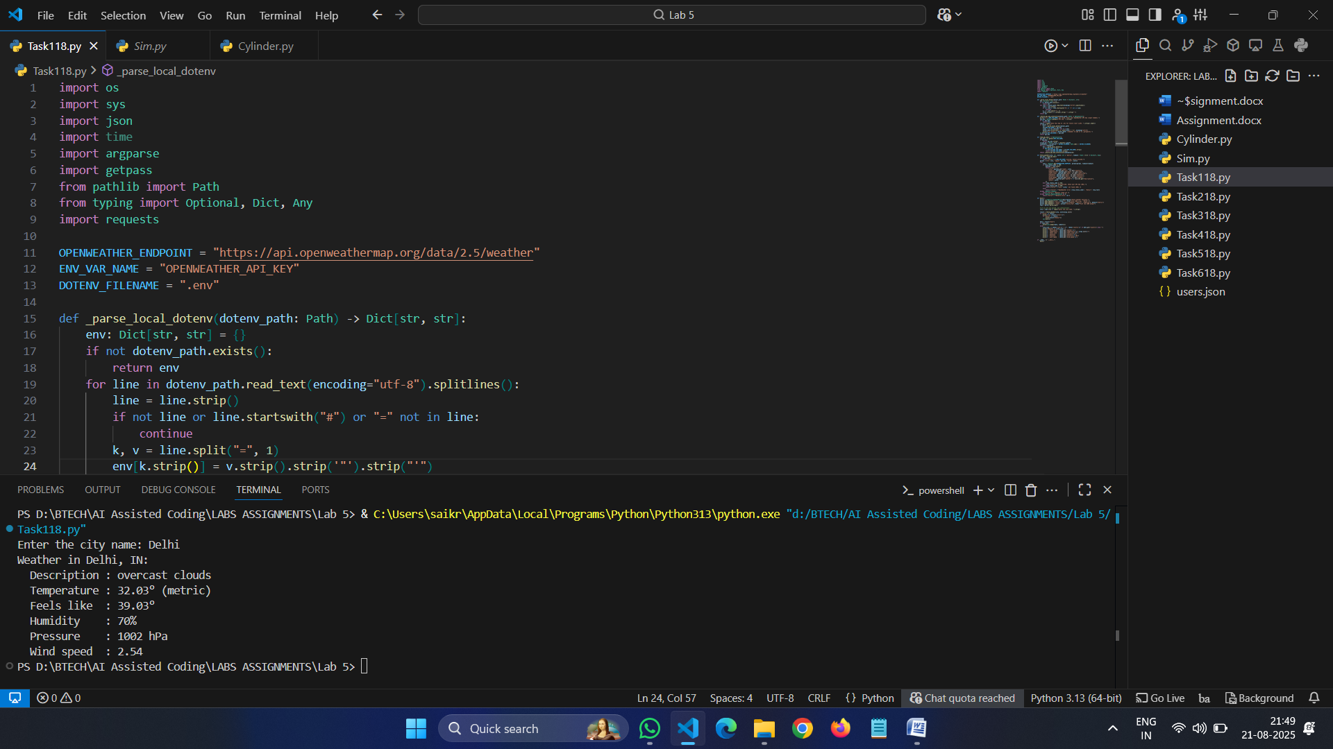**
* *Generate Python code for QuickSort and BubbleSort, and include comments explaining step-by-step how each works and where they differ.*

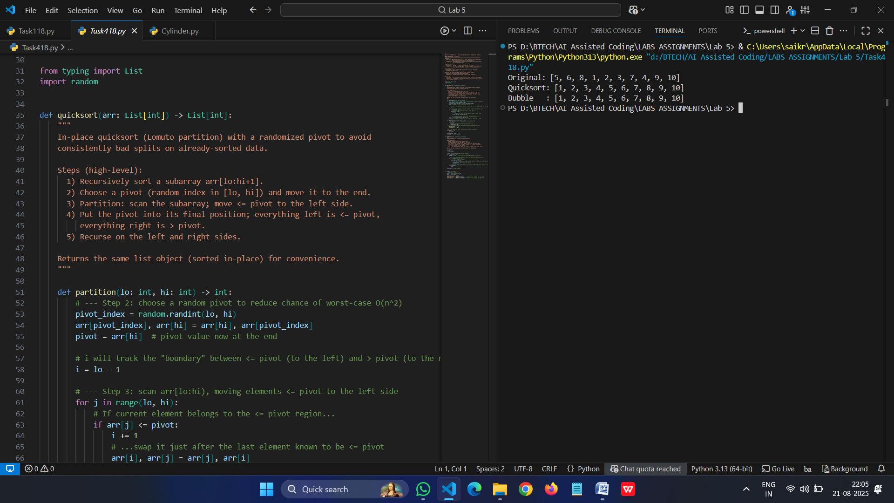

* *Generate a recommendation system that also provides reasons for each suggestion*

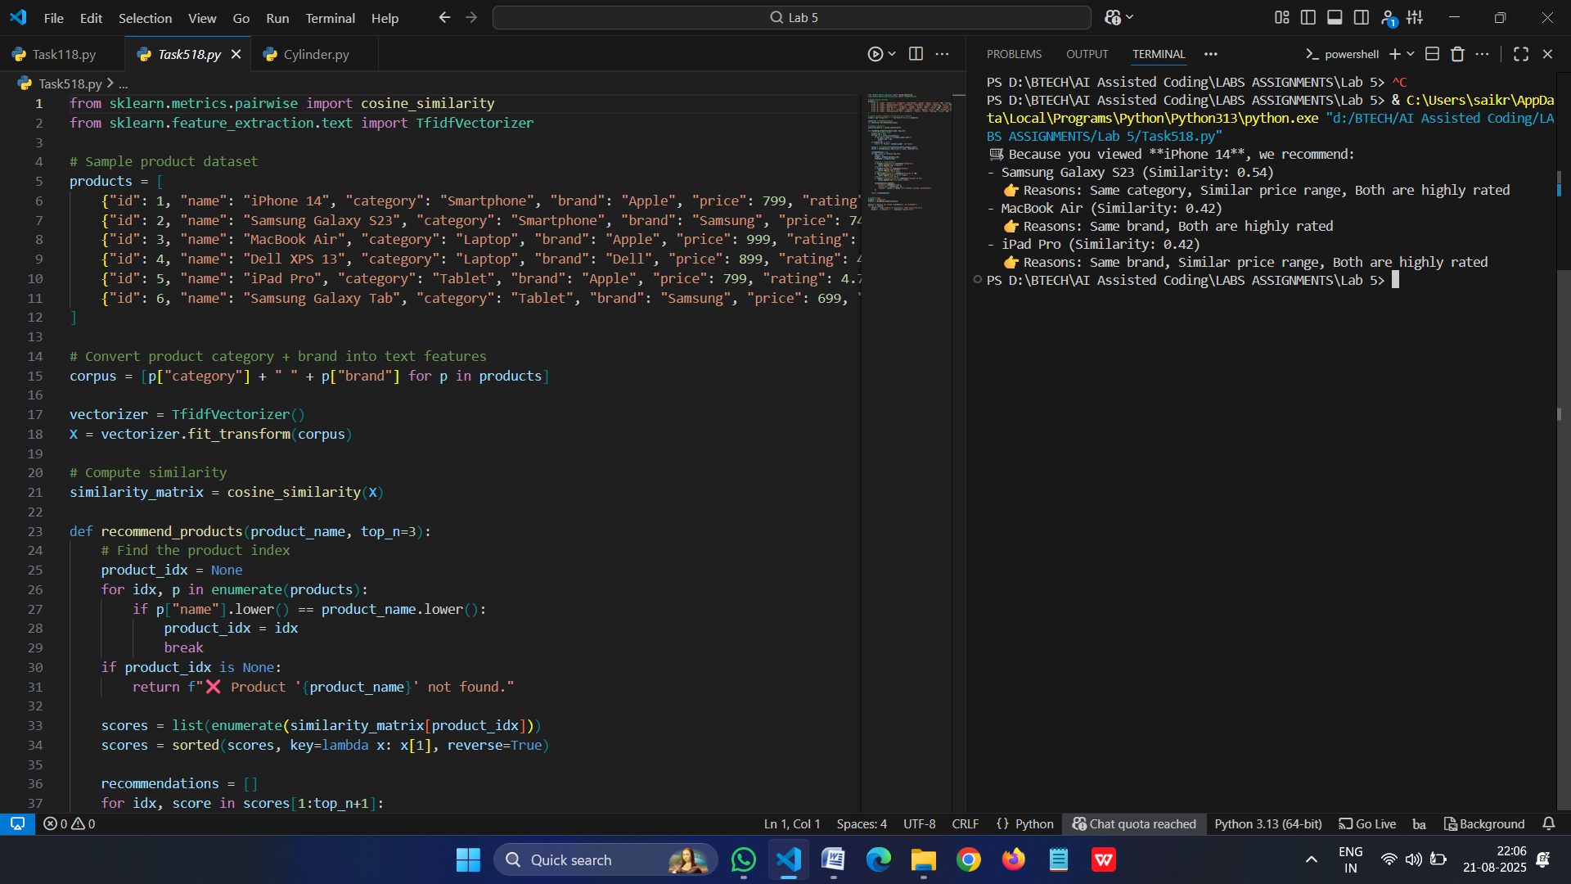

* *Generate a recursive factorial function with comments that explain each line and a final summary of the algorithm’s flow*

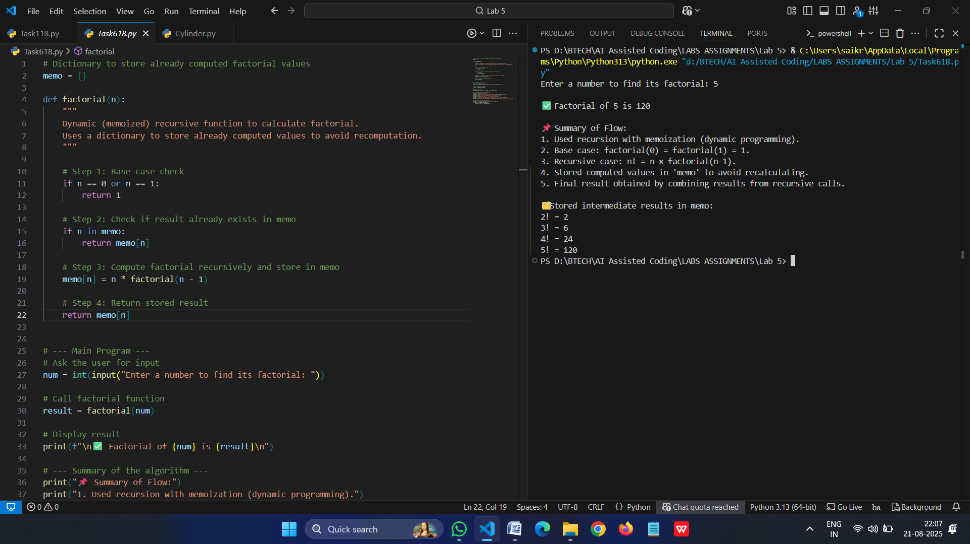

**•** Prompt GitHub Copilot to generate a Python script that collects user data (e.g., name, age, email). Then, ask Copilot to add comments on how to anonymize or protect this data.

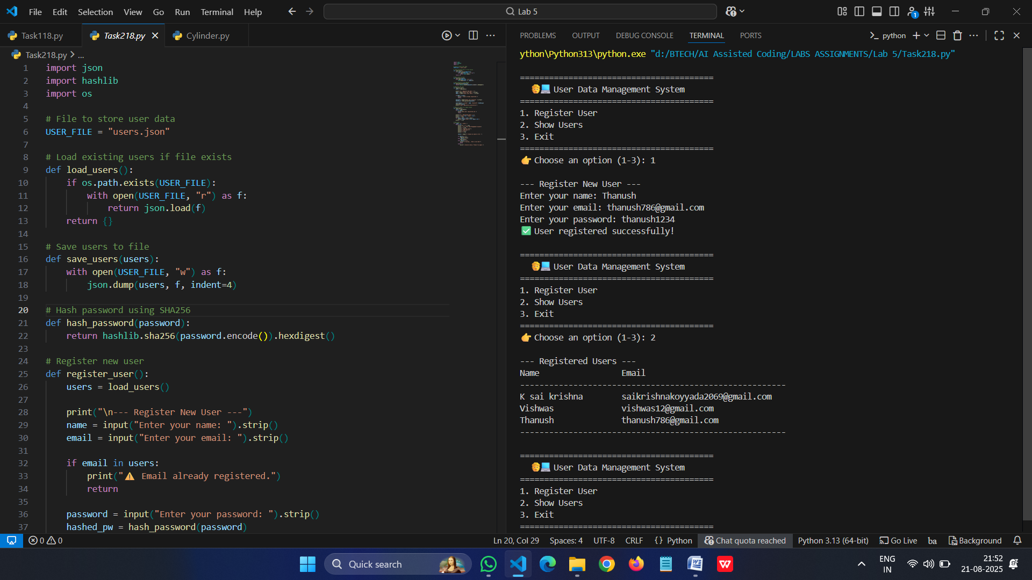

* Generate an Armstrong number checking function with comments and explanation.

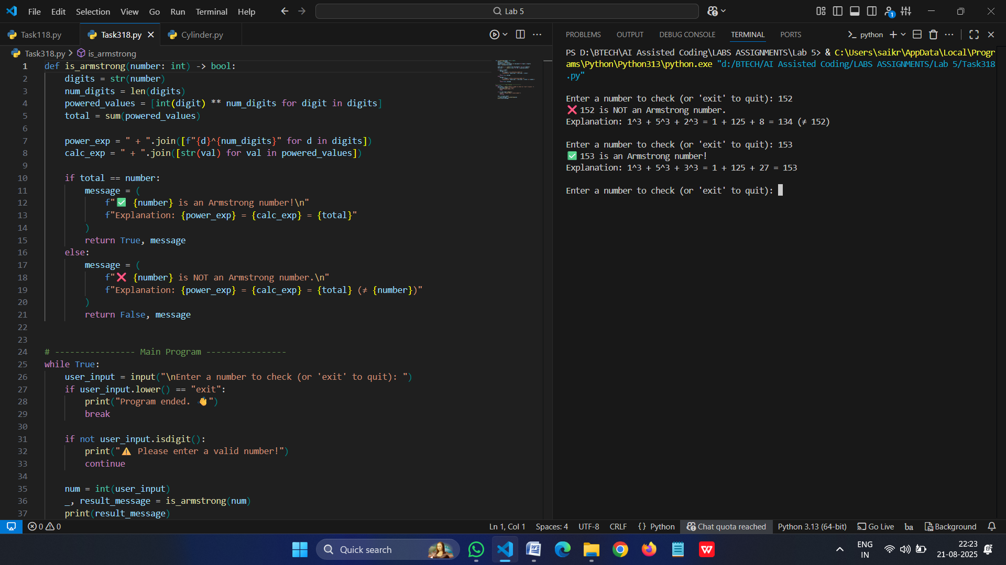

#2503A52L09